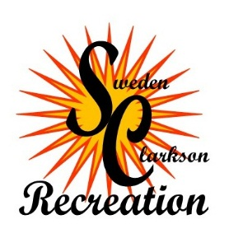
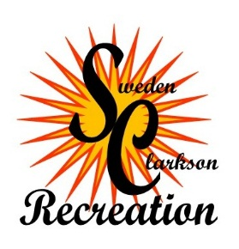

Sweden/Clarkson Recreation
4927 Lake Road
Brockport, NY 14420
Phone: (585) 431-0090
Fax: (585) 431-0052

Refund Request Form

Date of Request: ____/____/________ Refund Amount: _________________

Name: ____________________________________________________________________________________________
Address: _____________________________________________________________________________________________
Participant Name: _____________________________________________________________________________________________
Program Name:____________________________________Program Number:___ __________________________
Reason for Request: _____________________________________________________________________________________________

Refunds will be given to anyone who cancels from a program at least one week (5 working days) prior to the
start of the program, or in the case of sports programs, 3 weeks prior to the 1st practice.
There will be no refunds given for a program once is has begun.
A refund may be allowed in the event of illness or injury if a doctor’s note is provided.
All refunds will be subject to a $10.00 processing fee per person/per program.
Certain programs, such as the fitness center are non-refundable.

